SANDIPAN DAS

Sd901656@gmail.com

C Programming notes

**What is PROGRAMMING?**

Programming refers to a technological process for telling a computer which tasks to perform in order to solve problems. You can think of programming as a collaboration between humans and computers, in which humans create instructions for a computer to follow (code) in a language computer can understand.

**What is PROGRAMMING LANGUAGE?**

First of all we must to know first what is called language. Language is a mode of communication that is used to **share ideas, opinions with each other**. For example, if we want to teach someone, we need a language that is understandable by both communicators.

A programming language is a computer language that is used by programmers (developers) to communicate with computers. It is a set of instructions written in any specific language (C, C++, Java, Python) to perform a specific task. A programming language is mainly used to develop desktop applications, websites, and mobile applications.

**Algorithm Vs. Flowchart**

Algorithms and flowcharts are different mechanisms used for designing different programs, particularly in computer programming. An algorithm is a step-by-step summary of the procedure, while on the other hand, a flowchart illustrates the steps of a program graphically.

**What is an Algorithm?**

An algorithm is a procedure or set of rules that defines how a program is to be executed. Or we can say that it is a set of instructions for solving a well-defined computational problem.

**What is a Flowchart?**

A flowchart is a graphical representation of the steps a program takes to process data. In this, we can use several geometric patterns to illustrate the numerous actions the program carries out.

With the help of the flowchart, the designer can efficiently segregate the various elements of the process. Also, it facilitates the analysis by giving step-by-step instructions on the problem.

**Difference Between Algorithm And Flowchart**

|  |  |  |
| --- | --- | --- |
| **Parameters** | **Flowchart** | **Algorithm** |
| **Description** | A flowchart is a graphical representation of the steps a program takes to process data. In this, we can use several geometric patterns to illustrate the numerous actions the program carries out. | An algorithm is a procedure or set of rules that defines how a program is to be executed. Or we can say that it is a set of instructions for solving a well-defined computational problem. |
| **Complexity** | It is easy to design and also very user friendly. | It is comparatively difficult to create and also a bit challenging to be understood by a layman. |
| **Geometrical diagrams** | It utilizes different types of geometrical shapes, symbols, and patterns. | An algorithm does not include any sort of geometrical pattern. |
| **Scope of Usage** | A flowchart can be used in different disciplines to describe a process. | Algorithms are used in the domain of mathematics and computer science. |
| **Use** | A flowchart is used in documenting, designing, and analyzing a program in different disciplines. | An algorithm is used to represent the concept of decidability. |
| **Users** | A Flowchart doesn’t demand the knowledge of a computer programming language. | An algorithm demands the knowledge of a computer programming language. |
| **Debugging** | It is easy to debug the errors in flowcharts. | It is difficult to debug the errors in algorithms. |
| **Implementation** | In flowcharts, no rules are used. | In algorithms, predefined rules are used. |
| **Branching and Looping** | Simple to display branching and looping. | Hard to display branching and looping. |
| **Solution** | In a flowchart, the solution is represented in a graphical format. | In an algorithm, the solution is presented in non non-computer language. |

**Flow Chart Symbols: -**

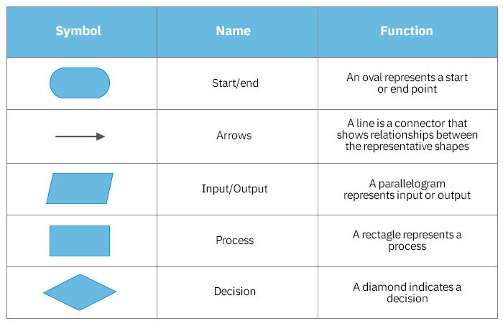

Step 1: Start

Step 2: Declare variables num1, num2 and sum.

Step 3: Read values for num1, num2.

Step 4: Add num1 and num2 and assign the result to a variable sum.

Step 5: Display sum

Step 6: Stop

### Flowchart:

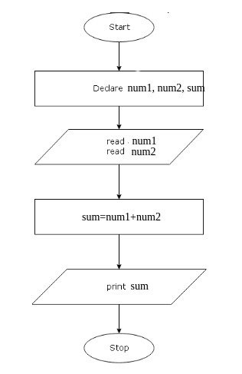

Home works: -

1. Algorithm: Write an algorithm to find the largest number among three numbers. Flowchart: Draw a flowchart to represent the algorithm.
2. Algorithm: Write an algorithm to check if a number is even or odd. Flowchart: Draw a flowchart to represent the algorithm.
3. Algorithm: Write an algorithm to calculate the area of a rectangle. Flowchart: Draw a flowchart to represent the algorithm.
4. Algorithm: Write an algorithm to check if a given year is a leap year. Flowchart: Draw a flowchart to represent the algorithm.
5. Algorithm: Write an algorithm to print the multiplication table of a given number. Flowchart: Draw a flowchart to represent the algorithm.
6. Algorithm: Write an algorithm to check if a number is a prime number. Flowchart: Draw a flowchart to represent the algorithm.
7. Algorithm: Write an algorithm to find the sum of the first N natural numbers. Flowchart: Draw a flowchart to represent the algorithm.